STEGO Elektrotechnik GmbH, Schwäbisch Hall, Germany, 15 June 2022:

. P r e s s R e l e a s e .

(3,827 gross characters) .

Ground breaking at Stego

The electronic component manufacturer is investing 7 million in a new office building

Schwäbisch Hall (Germany), 15th June, 2022: the electronic component manufacturer Stego is expanding its capacity at the group's headquarters in Schwäbisch Hall. A doubling of warehouse volume for production is already complete. The construction of an office block is now starting. This should be completed by the end of 2023 and provide space for over 70 employees with 1,500 square metres.

Growth in a feel-good atmosphere
The Stego Group in Schwäbisch Hall is growing. Even during the pandemic. Almost without restraint. Rising product demand has led to a strain on material supply and logistics. The doubling of warehouse volume of the fully automated warehouse completed in May provided relief here. The workforce, which is driving and managing the growth, is also growing, however. In the first half of 2022 alone, staff numbers at Stego increased by 10% to now 150 employees. The new construction provides offices for the growing number of staff and an atmosphere for efficient and creative working. Bright, spacious offices with flexible workstations should facilitate the agile cooperation of the present. However, relationships with customers and suppliers should also be supported. A representative showroom for displaying Stego products and services will become the hub of the reception area in order to provide appropriate space to convey the company's values and brand promise.
A low CO2 footprint was ensured during planning. The two-storey structure of 1,500 square metres is designed to what is currently the most stringent German building standard for energy efficiency, KFW 40, and provides 70 office desks, staff rooms and an integrated canteen. The photovoltaic system on the roof of the new construction is also environmentally friendly. It provides the machines in production with sustainably produced electricity.

Visible champion
"We are no longer a hidden champion. Today, we want to be a visible one", is how Elmar Mangold, Managing Director, summarises the alignment for the future of Stego. The positive business development of the internationally active family company gives room for this view. After all, the traditional line of business – thermal management applications – is booming worldwide. Stego's workforce now boasts some 220 employees, of which 70 are in branches abroad. The requirements for manpower are manifold. For example, engineers and programmers are sought for the development in hardware and software. Especially also in sales, production and logistics, however, staff are sought to cover the increased customer requirements. The company headquarters in Schwäbisch Hall controls a total of nine branches, located in Europe, the USA, Brazil and a sales office in China. With an export ratio of over 70%, internationalisation is one of the keys to the company’s success. The last decade bestowed the company with constantly increasing sales. New products are the key driving force behind this development. For example, in autumn 2022, half a dozen new products are being introduced to the market at the SPS trade fair in Nuremberg. The foci here are control cabinet heaters in the new loop design and sensors for measuring condition data in industrial systems.

Digital solutions
Stego invests in the digital future. For example, the medium-sized company from Schwäbisch Hall offers an in-house-developed platform for Industry 4.0 for the condition monitoring of industrial systems: Stego Connect. The Web-based service enables the operation of intelligent factories using the IO-Link protocol developed in Germany. With Plug & Connect, distributed sensors and machines in the production plants are centrally configured, monitored and controlled in the cloud application.

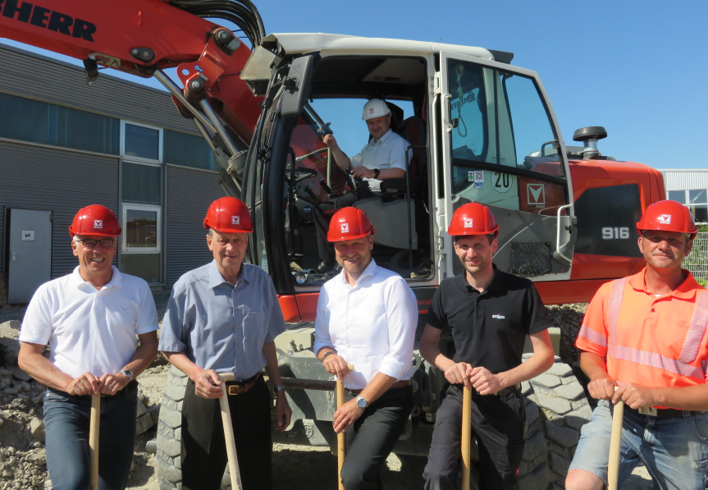

New office building at Stego; above: Stego CEO Elmar Mangold; from left to right: architect Günther Obinger, Stego founder Isidor Gloning, Stego head of sales and marketing Martin Sitter, Stego head of facility management Matthias Schickert, Hans Fuchs Constructions site manager Andreas Hankele

STEGO – Perfect thermal management

Since its founding in 1980, STEGO Elektrotechnik GmbH in Schwäbisch Hall, Germany, has been developing, producing and distributing a constantly growing product range for the protection of electrical and electronic components. Enclosure heaters, filter fans, LEDs, thermostats, humidity switches and control cabinet accessories ensure optimised climate conditions in a wide variety of environments and ensure the permanently reliable operation of sensitive components.
With Stego Connect, Stego offers an intuitive cross-manufacturer IIoT platform solution for IO-Link devices. As an integrated digitalisation solution, this software-as-a-service opens up a quick and simple entry into Industry 4.0 applications based on the IO-Link technology.

www.stego.co.uk
www.stego-connect.com/en/

Contact:
Siegfried Oerthel | soerthel@stego.de | Tel. +49 791 95058-181

STEGO Elektrotechnik GmbH
Kolpingstraße 21
74523 Schwäbisch Hall
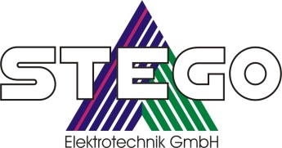
Germany
Scan me for
STEGO NEWSROOM

